INDIA NEWSLETTER
MAIL DATE: FIRST WEEK SEPTEMBER ‘21
BEST MONTHS: DECEMBER
Festivals: Ranthambore Music Festival (Ranthambore, India)
Hornbill Festival (Nagaland, India)
Trongsa Festival. (Trongsa, Bhutan)
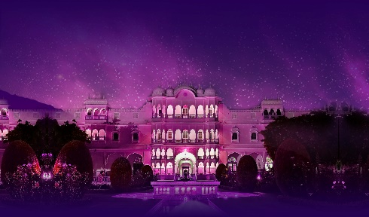
- Ranthambore Music Festival (Ranthambore India): Some music festivals are focused only on the music, while others add a cause to their line-up and promote an issue as well. The third edition of Ranthambore Music & Wildlife Festival, to be held in December, will be a mix of both. The 2 nights 3 days-long cultural fiesta will be held at the Nahargarh Ranthambore and will focus on both the need to preserve India's wildlife and the promotion of dying musical forms. The festival will do so through a spectacular banquet of world music, art, food and wildlife experiences.
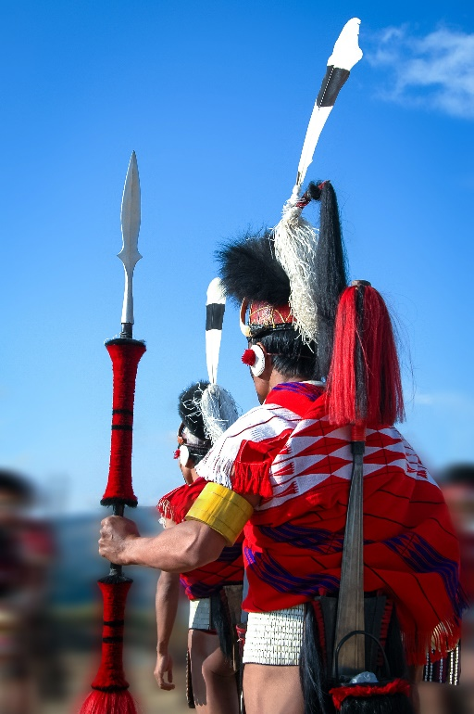
- Hornbill Festival (Kohima, Nagaland, India): The Hornbill Festival is one of the largest celebrations of the indigenous warrior tribes of Nagaland. Naga people have a rich tradition of maintaining their unique heritage and customs. For this reason, people plan their visit and book Nagaland Hornbill Festival tours so that they can experience the uniqueness of this tribe and spent some time with the locals.
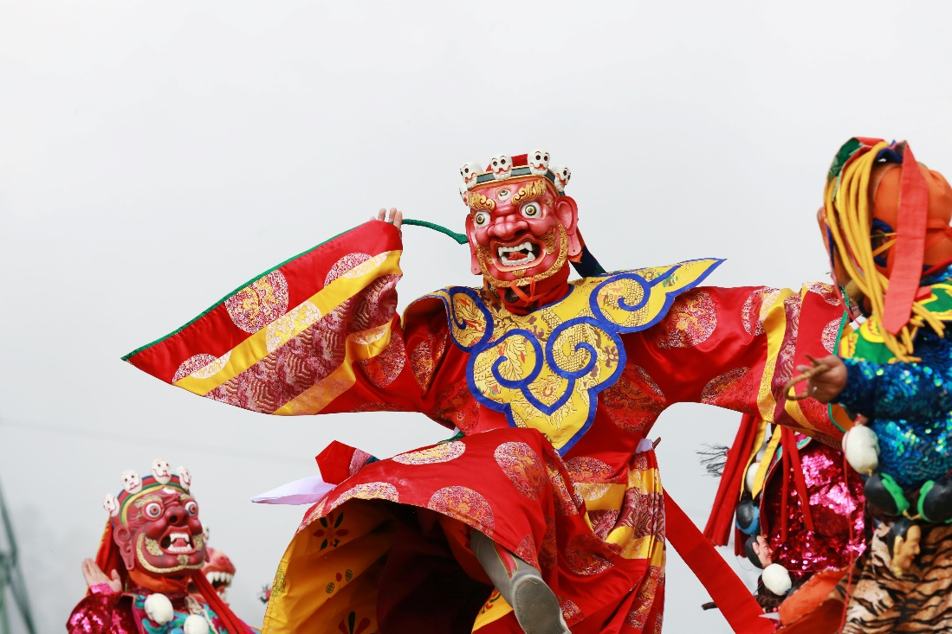

- Trongsa Festival. (Trongsa City, Bhutan): The Trongsa festival is one of the grandest annual festivals that bring together people from all walks of life. This festival is also called the winter festival of Bhutan, which falls sometime in the month of December. Apart from witnessing traditional mask dances, this Trongsa festival tour will also offer visitors to explore unfurling of the sacred Thongdrol and receive blessings from high ranking monks.
CITIES TO VISIT: Ranthambore, Kohima, Nagaland, and Trongsa, Bhutan
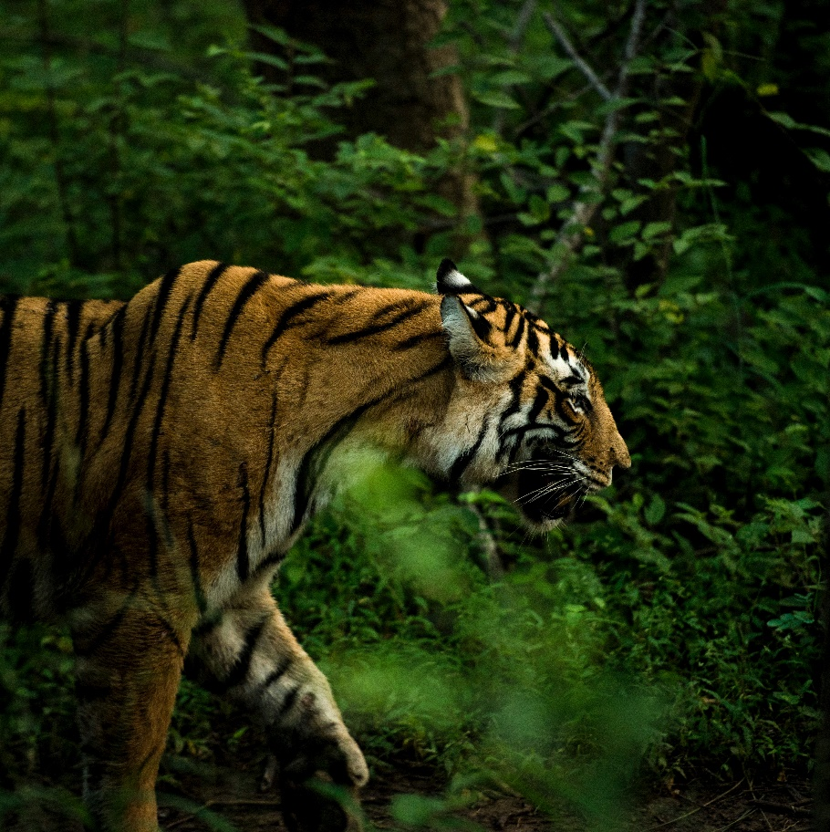
- Ranthambore. (natural vegetation and wildlife reserve) : The popular Ranthambore National Park and Tiger Reserve was once the private game reserve of the royal family of Jaipur., Ranthambore's diverse topography with a mix of rolling hills and crags, meadows, lakes and rivulets, offers some of the finest opportunities for sighting the magnificent tiger in the wild. Apart from the tiger, other wildlife in the park includes sloth bear, leopard, jackal, fox, hyena, Indian wolf, chital, sambar deer, blue bull antelope or nilgai, rhesus macaque, langur and an incredible variety of birds. The 10th century Ranthambore fort dominates the landscape of this dry-deciduous forest.

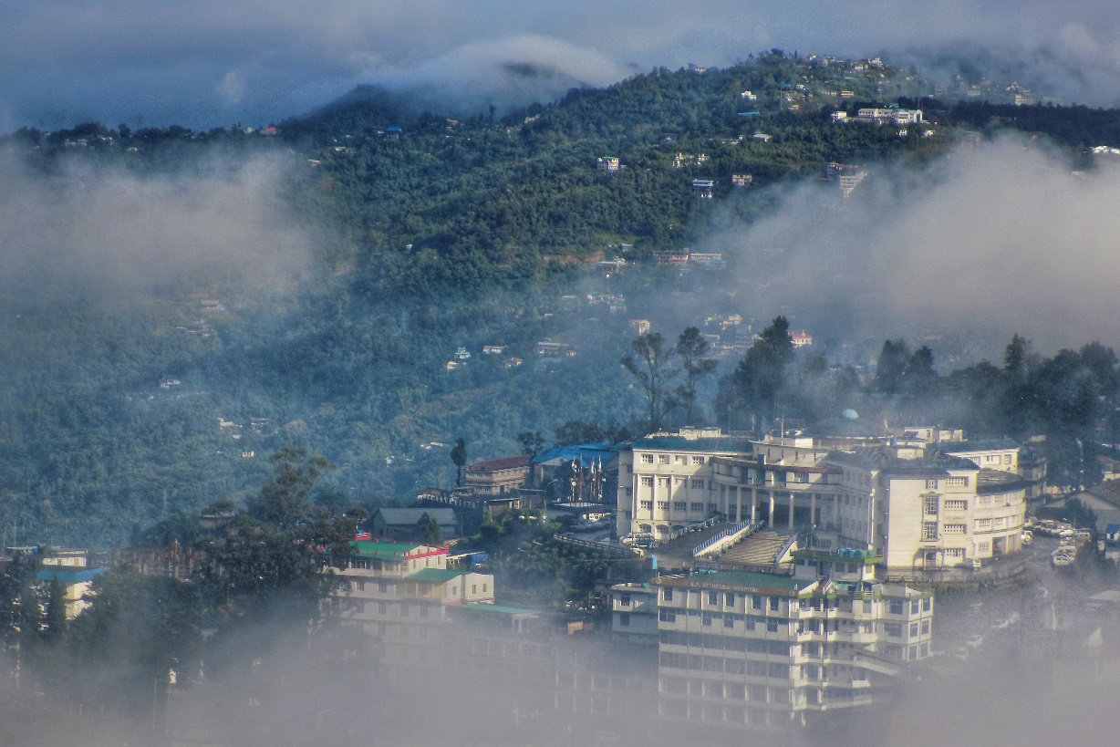
- Kohima, Nagaland, India: Nagaland has had a tradition of hosting tourists for decades. its glorious past and rich heritage and culture. For the adventurous and the intrepid, Nagaland is an ideal place for trekking, rock climbing , jungle camping and offers limitless exploration possibilities in its lush and verdant sub-tropical rain forests which are also a treasure trove of a plethora of medicinal plants. Above and beyond tourists can also experience a truly ethnic Naga Culture with the best local brews served in large bamboo mugs and exotic local cuisines which is much celebrated here.
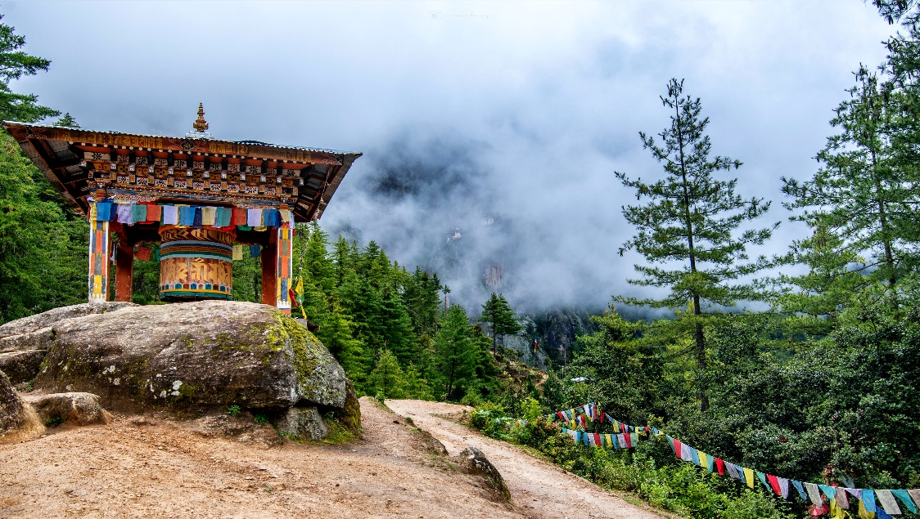
- Trongsa, Bhutan : The Birthplace of Bhutanese Kings: A town that holds high historical and political value in the Land of Thunder Dragons, Trongsa sits atop an enchanting ridge in the central part of Bhutan. This historical town was once the seat of power of Bhutan’s Wangchuck Dynasty that ruled the country in 1907. Even till date, there is a political tradition that the heirs to the throne of Bhutan should first become the ‘penlop’ (governor in local language) or Trongsa.
DESCRIPTION:

December is a fantastic time to travel to Ranthambore and the neighboring states: North India is one of the best places to visit in India in December as you can use the full day for activities and sightseeing without it being excessively hot. Temperatures can drop to below 10ºC. Hotels will supply warm blankets. Prepare for this and pack warm clothes, scarfs, maybe even a hat and gloves, especially for the desert and jungle safari.

The best time to explore Bhutan is during the month of December. Bhutan weather in December marks the beginning of winters and, hence, the temperature of Bhutan in December is moderately cool, skies are clear, and the place is not much crowded which creates an ideal environment for a trouble-free and cost-effective Bhutan tour in December.

HOTELS:
Where to stay
City
Ranthambore, Rajasthan, India | Aman -i- Khas
Kohima, Nagaland, India | Kohima Camp Nagaland
Trongsa, Bhutan | Yangkhil Resort

Aman -i- Khas

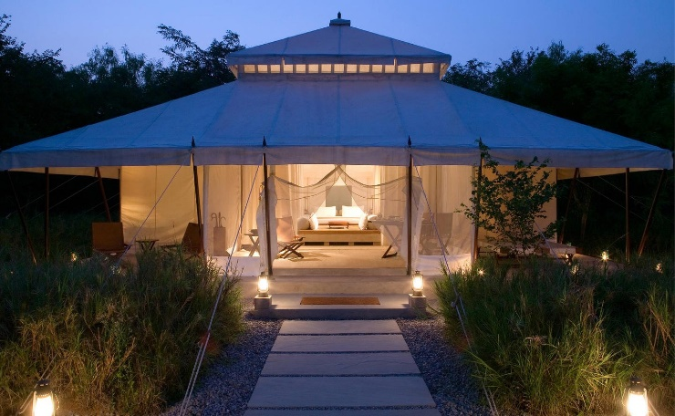

The domain of the majestic Bengal tiger, Ranthambore National Park is starkly beautiful, its green and gold hues the perfect backdrop to Aman-i-Khás. Situated on the threshold of the reserve, this intimate tented camp offers incomparable privacy and daily safaris seeking out the reserve’s wildlife. Back at camp, spa therapies, swimming and dining take centre stage.

Kohima Camp Nagaland

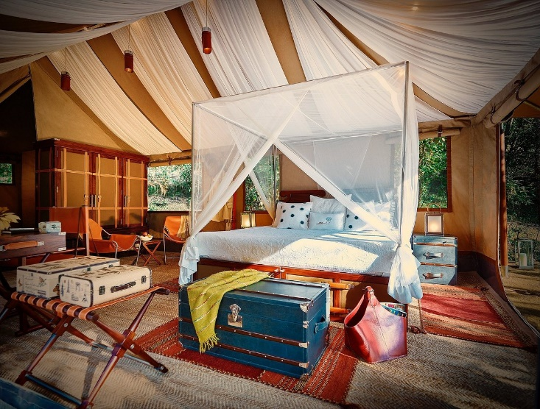

This nomadic super luxury camp introduces the discerning traveller to different adventures in carefully selected exceptional locations in the mountains, deserts, jungles and unexplored countryside. Experience the many moods of exotic India with its dramatic landscapes, rustic and unexplored rural surroundings. At our Kohima camp celebrate tribal hues at the Hornbill Festival, explore quaint tribal Naga villages, or simply curl up in your 'tent with a view' and so much more…

Yangkhil Resort

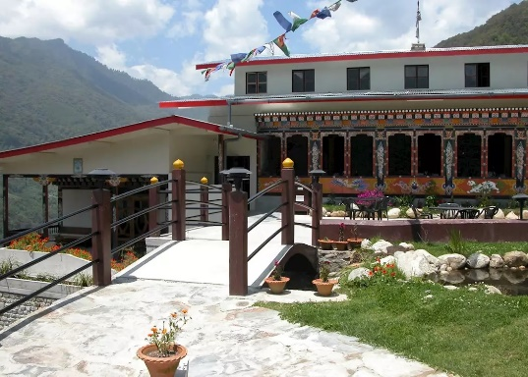
The Yangkhil is located two kilometres outside Trongsa, has 21 spacious rooms of modern design combined with traditional Bhutanese architecture and wooden flooring. All rooms are fully insulated and the bathroom has a bath tub with a shower over. Hot and cold running water is available all day long.
There is a small business centre, convenience store, and lounge, restaurant, bar, and outdoor dining in warm weather. The garden is brightly decorated with a traditional bridge, water wheel and pond with spectacular views of the Trongsa Dzong and the Mangde River.

RANTHAMBORE.
ACTIVITIES / SITE SEEING:
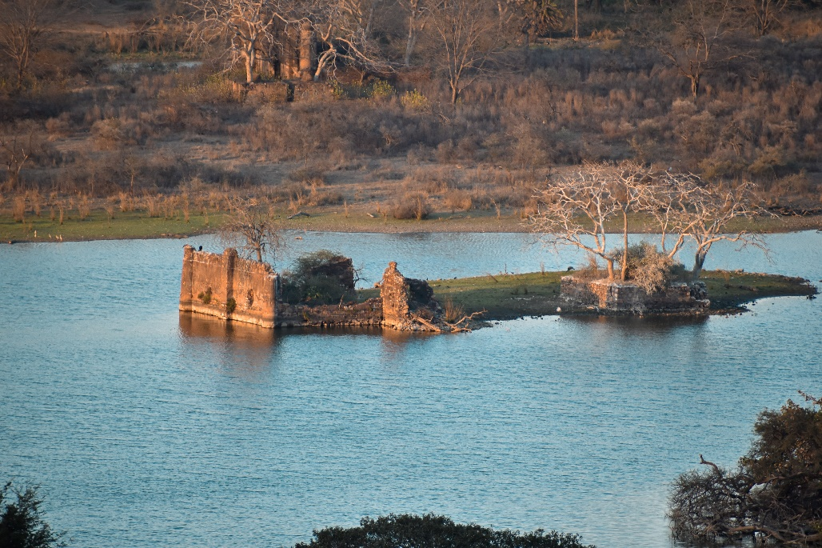
Go on a tiger's trail, Hike up to Ranthambore Fort, Jungle Safari in Ranthambore National Park, Visit to Kachida Valley, Visit Ranthambore Schools of Art, Walk around Padam Talab and many other adventurous activities to do.

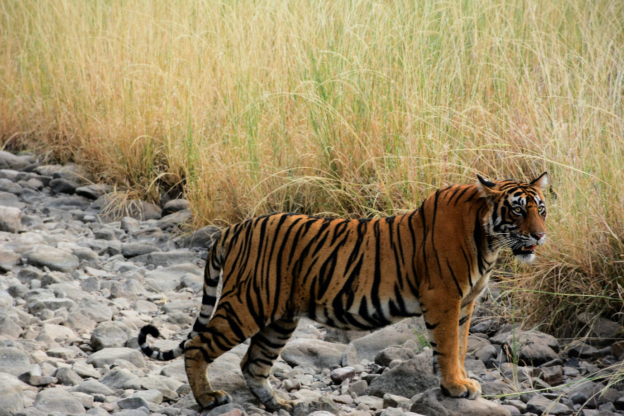
Located in South-Eastern Rajasthan and home to many endangered tigers, you will be provided with an array of adventurous Things to Do in Ranthambore. Also known as the Tiger Reserve of Western India, the tiger population here has attracted flocks of tourists from all over the world.
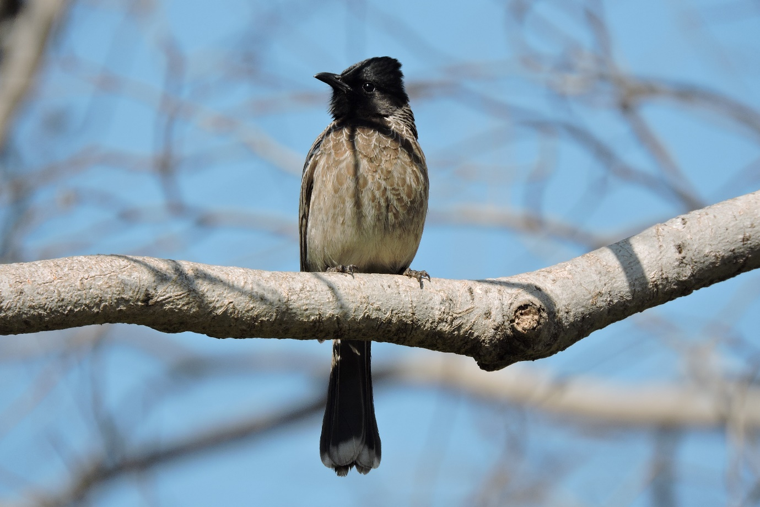
From sighting the tigers and other exotic wildlife species to catching a glimpse of rare exotic migratory birds, one can enjoy a lot in this small town in Rajasthan. Some of the best things one can do here are going on a jeep safari and canter safari, which guarantee a great wildlife sighting experience.
PRODUCTS:
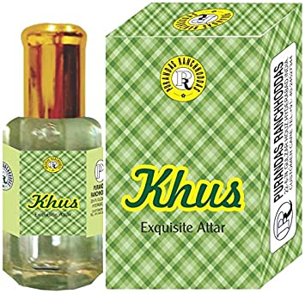

KHAS PERFUME, The fragrance of different perfumes, can buy the immensely famous khas perfume. It is made from the local plant and is sold in many beautiful bottles. You can also get the very special gift bottles in here, and then there is also availability of khas fresheners. The other parts of the plant are also used for making boxes and fans.

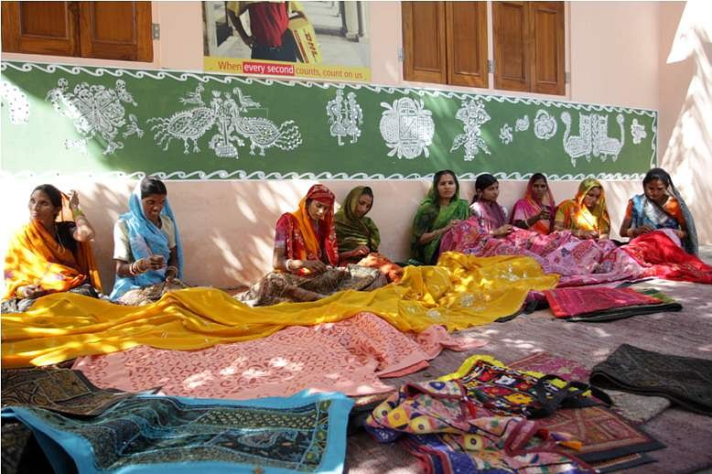

THE HANDICRAFTS, The Village Women Craft, Ranthambore helps the local women to be financially and socially comfortable, thereby encouraging the continuation of the traditional arts and crafts.
CAMEL LEATHER, Since this city has a rich historical heritage, the tourists can also shop for unearthed artifacts. Then there are also shops which sell the accessories made of camel leather. These accessories are specially liked by the international tourists.

CULINARY DELIGHTS OF RANTHAMBORE:
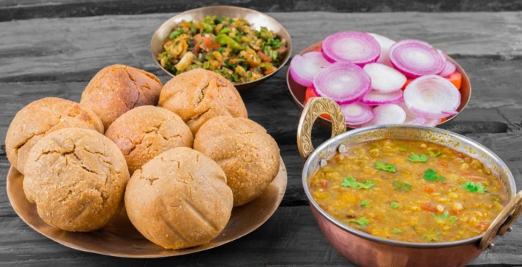
Dal baati. It is a spicy yet very rich dish, which is served with lot of butter. The must taste deserts include the jalebis and churma ladoo, very mouth watering.
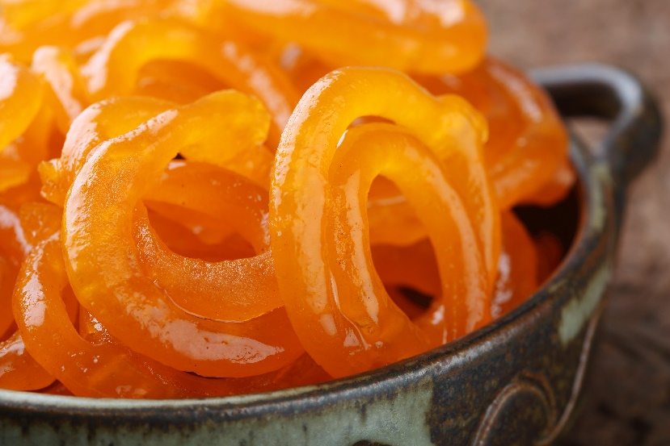
jalebis and churma ladoo .The must taste deserts include the jalebis and churma ladoo, very mouth watering. The hospitality of the restaurants is such that the spicy flavor of the dishes can be regulated if needed.
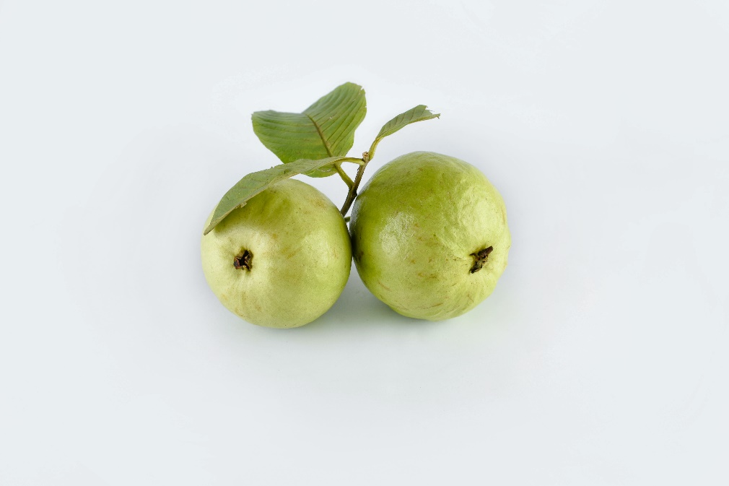
GUAVA. For the tourists who like fruits, there are many shops sprinkled round the city, which sell guava. These guavas are famous round the country, and are of export quality. In fact considering the fact that guava can be used in many dishes including chutneys. These will make sure to savor your taste buds.

NAGALAND
ACTIVITIES / SITE SEEING:
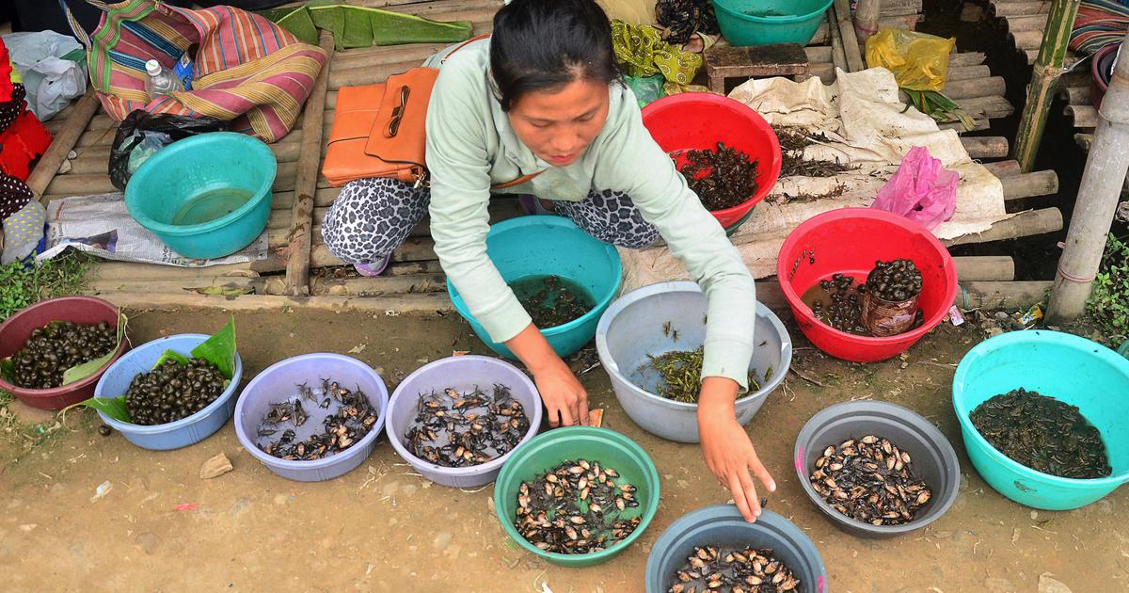
Keeda Bazar
A way to a city’s heart is usually through its food-—visit the Naga Market where locals stock up on all kinds of meat, vegetables and a fair share of creepy-crawlies. From honeycombs, rabbits in bamboo crates, silkworm larvae, Borol—a larvae delicacy of hornet grubs; tadpoles in plastic bags, forest ferns, fermented tofu and beef to the super hot Raja Mirch chillies, you’ll find it all here. The atmosphere is lively with Naga women dressed in shirts and sarongs, chewing betel leaves, selling slabs of pork, beef and even dog meat. Warning: not for those with weak stomachs.
Dzukou Valley Trek
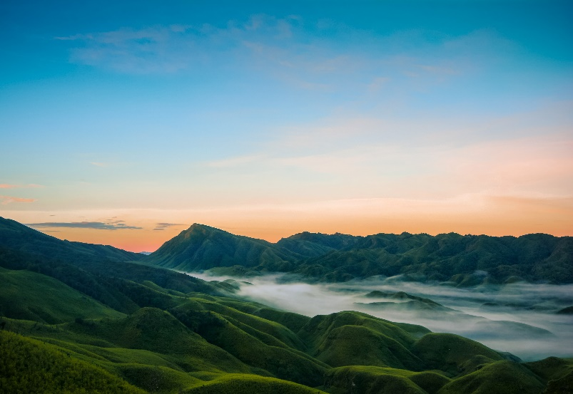
Blessed with absolutely mesmerizing beauty, Dzukou Valley (2438m) is situated at a distance of about 30kms from the state capital, Kohima. Gorgeous Dzukou valley is a trekker’s delight and is reckoned to be the best trekking circuit in the country. Dzukou Valley to Nagaland is what Valley of Flowers is to Uttarakhand.

Bite into the world's hottest chilli

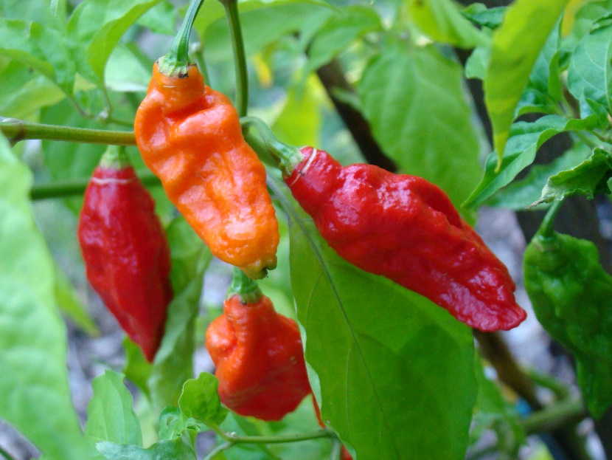
A typical Naga meal has sticky rice, smoked meat (either dry or pork with bamboo shoots); fish steamed in hollow bamboo tubes with some spices, boiled vegetables, and spicy chili sauces. The Bhut jolokia—one of the hottest chilies in the world is native to the region and used in many local recipes. Also try the fried momos and wash them down with zuthou, a sour rice beer. Vegetarians, there are all kinds of fiddlehead ferns, lai (leafy greens), to experiment with. Be sure to try galho, the local version of khichdi.

PRODUCTS:
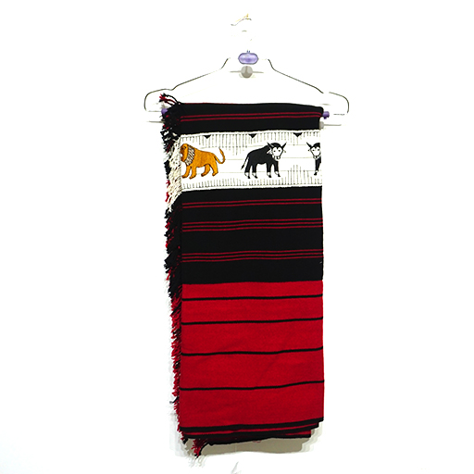
Naga shawl, The Naga shawl is recognised by its red, black and white colours and distinctive tribal prints. In the state of Nagaland, these shawls were once worn by revered warriors of different native tribes and just by looking at the design of the shawl.
https://madeinnagalandcenter.in
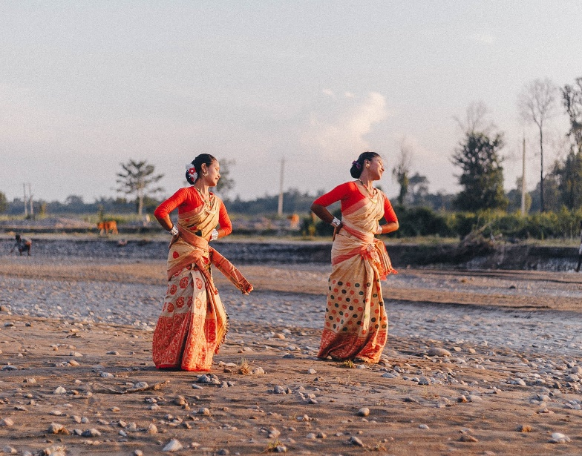
Mekhela chador, Mekhela chador is a traditional dress worn by women in Assam. While it looks similar to a saree, mekhela chador is actually a two-piece garment. The bottoms part is called the mekhela and is wrapped around like a sarong and the top part is draped around the body.
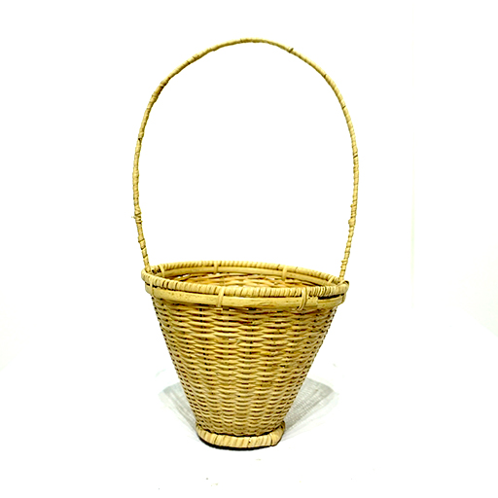
Meghum khoks basket, In most parts of Northeast India, the climate is highly suitable for the cultivation of cane and bamboo. This is why these plants have been used extensively by the locals for crafting items of everyday use and even for building houses
https://madeinnagalandcenter.in/product-category/handicraft/

CULINARY DELIGHTS OF NAGALAND
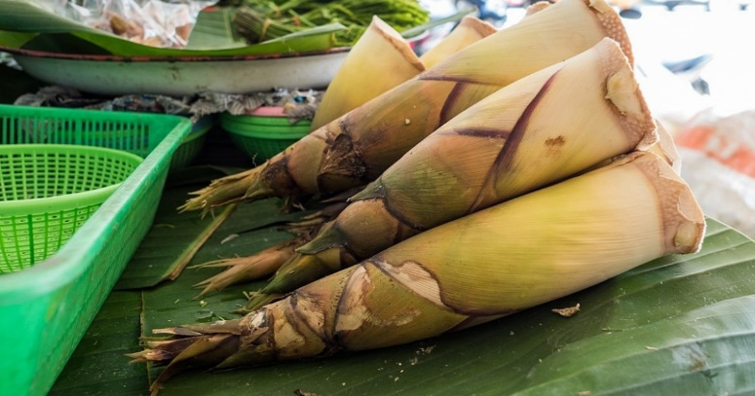
Bamboo shoot. Sliced Bamboo Shoots (Source) , Also the bamboo shoot based diets are rich source of dietary fibres and phytosterols and less cholesterol contents which make them one of the popular natural health foods.
Fermented dry fish, Gutted whole or split fish are packed between layers of coarse sea salt and fermented for one to three days. They are then sun-dried. Consists of a Greenland- or basking shark cured and hung to dry for four to five months.
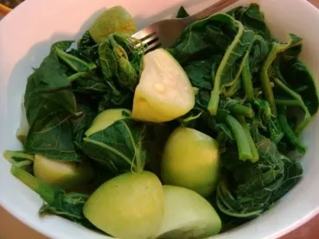
Aikibeye is a dish that comprises of Mustard leaf and Colocasia roots. This dish is cooked with very little salt and no spices giving it a bland flavour making it perfect for being eaten with the flavorful and spicy Non- Veg dishes of Nagaland.

TRONGSA, BHUTAN
ACTIVITIES / SITE SEEING:
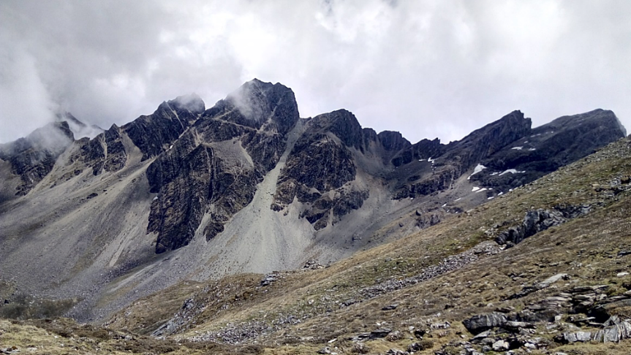
A magnificent hilly town situated at the center of Bhutan, Trongsa seeks to make an intimate connection with nature lovers, backpackers and honeymooners with spectacular sights of the black mountains, deep surrounding valleys, impressive Dzong and watchtower and numerous other visual and touristy delights.
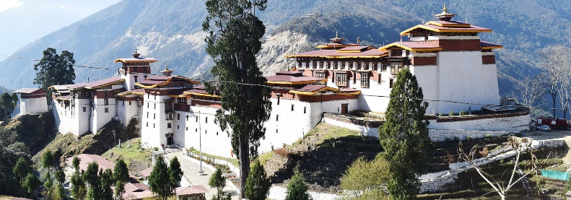
Apart from this, the town of Trongsa also boasts a massive and spectacular Ta Dzong. A must-see place, this towering watchtower is the main fortress of Trongsa and has been guarding the entire district of Trongsa since times immemorial.

Jigme Singye Wangchuck National Park
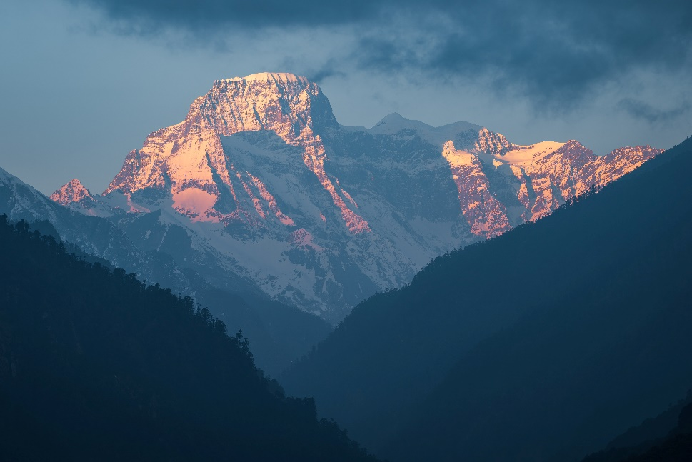
A perfect example of serenity in nature, Jigme Singye Wangchuck National Park is one of the country's largest national park areawise. Located in Trongsa and occupying parts of other districts such as Wangdue Phodrang also, it is a popular birdwatching spot in Bhutan.
PRODUCTS:
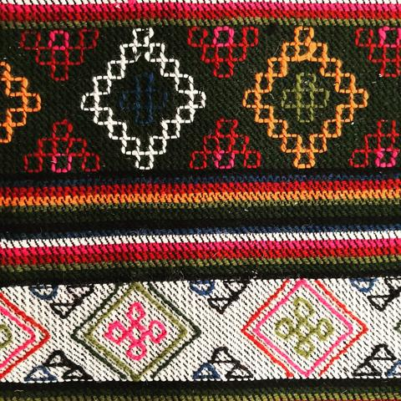
Yathra Art, The town of Jakar in the central-eastern region of Bhutan is a hub of Yathra made gifts and bags. Yathra is a vibrant and colourful woollen cloth which is also used to make jackets, wall hangings, rucksacks and blankets.
Silverware in Bhutan, In Bhutan, one can also shop for some intricately crafted silver treasure chests that are adorned with turquoise and amber and decorate their homes with them
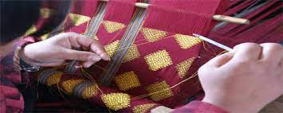
Adang Village and its Handloom,The hand-woven textiles of Adang Village in Wangdue Phodrang like Adang Rachu, Adang Mathra and Adang Khamar are praised all over the world for their wonderful and intricate designs and creativity.

CULINARY DELIGHTS OF TRONGSA
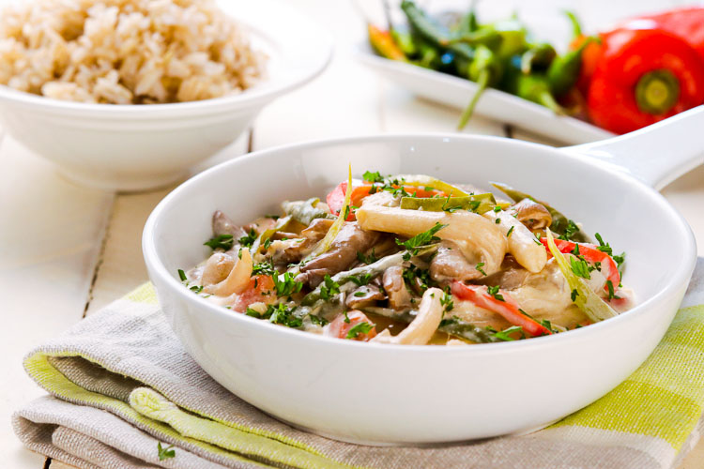
Ema Datsi/Datshi, The national dish of Bhutan, is a source of great pride for the people here and it is known for the generous doses of dried or fresh red and green chilies in it. Consisting of Ema (Chilli) and Datshi (Cheese), this famous Bhutanese dish has spun out many other variants like the Kewa Datshi (Potato and Cheese) and Shamu Datshi (Mushroom and Cheese) among others.
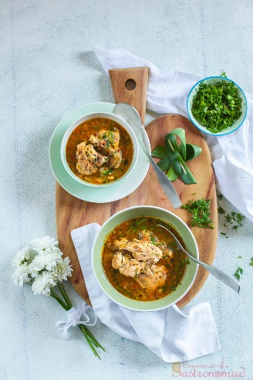
Jasha Maroo (Light Chicken Stew, Bhutanese Style) Jasha Maroo. A rustic chicken stew. Chicken cooked in a medley of onions, leeks and tomatoes. The warmth of ginger. The fire of chillies. A profusion of coriander leaves to finish the dish with.
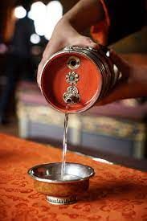
Ara - traditional alcoholic beverage. Bhutan, is a traditional alcoholic beverage consumed in Bhutan. Ara is made from native high-altitude tolerant barley, rice, maize, millet, or wheat, and may be either fermented or distilled. The beverage is usually a clear, creamy, or white color.

